You’re Invited
To Mother’s Day Tea!
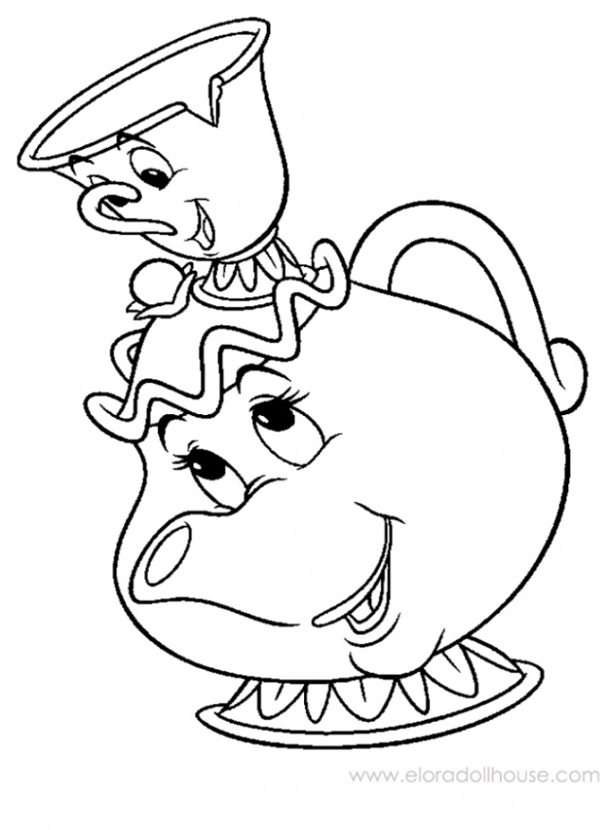

When: Thursday, May 10th
Where: Pre-K Classroom
Time: 10:30 – 11:30am

* If you are unable to attend due to other commitments, feel free to invite
a relative (aunt, grandma, etc.) or a family friend.

------------------------------------------------------------------------------------------------------------------------------------------------------------------------
Mother’s Day Tea
Family Name: _____________________________________________________
Yes, I will attend.
No, I cannot make it. My child will have __________________________________as a special guest.

